**MILESTONE 3- STOCK MARKETING**

**NAME:** T.MANIPRIYA

**EMPLOYEE ID:** 761131

**MAIL:** [Manipriya.T@cognizant.com](mailto:Manipriya.T@cognizant.com)

**LOCATION:** Siruseri, Chennai

**Displaying stock price details by company id**

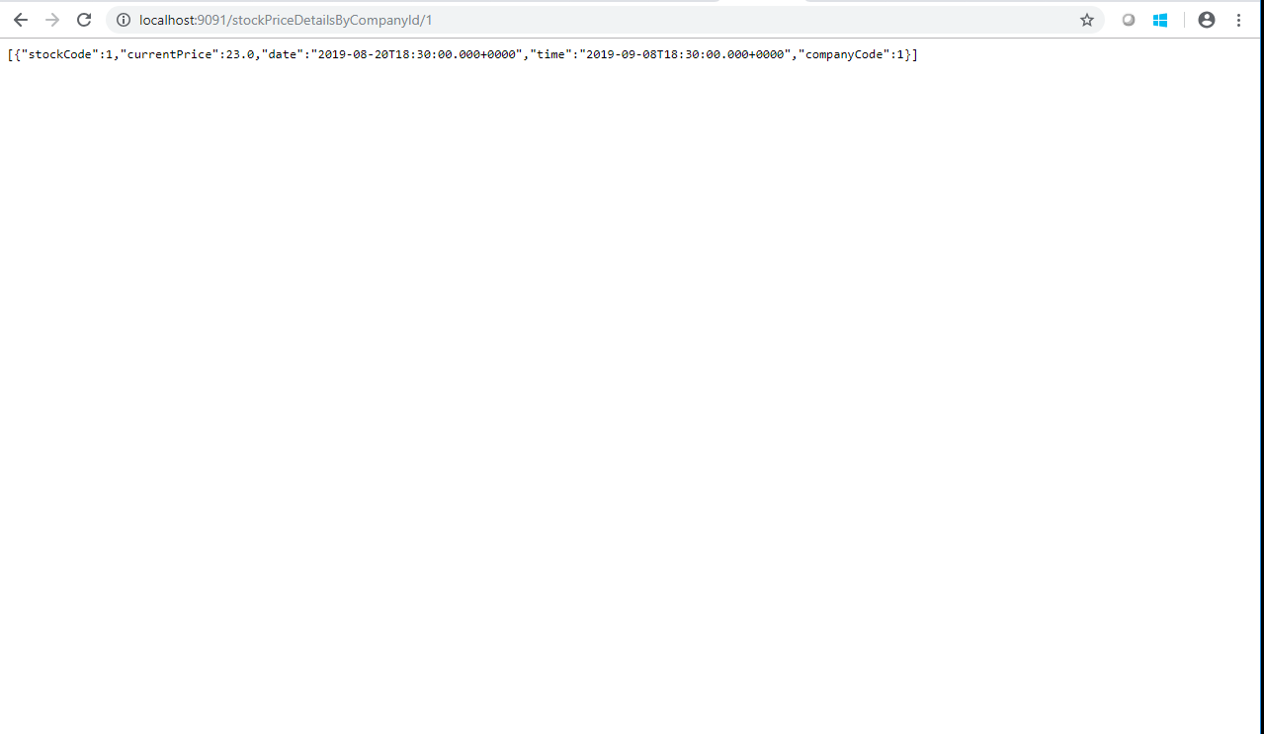

**Displaying ipo details by company id**

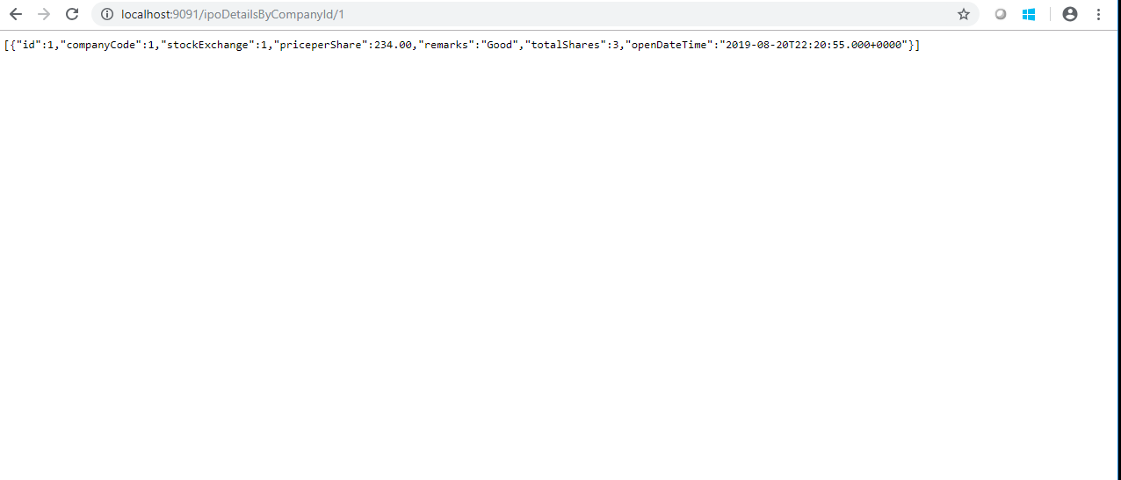

**Displaying matching company Details by Company name**

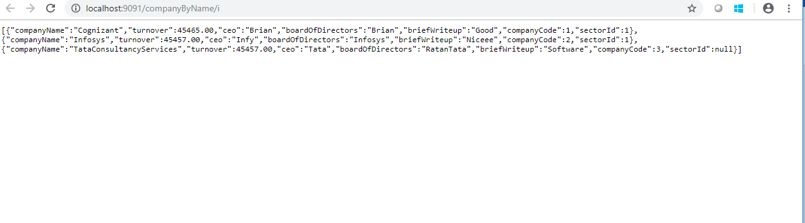

**Displaying company Details by Sector ID**



**GITHUB LINK:**

<https://github.com/ManipriyaThirumurugan/Stock-Exchange-SpringRest>